Practical - 6
Practical Title: Rendering External JSON Data using Fetch API, Search and Filter

Problem Definition: Display event lists, student profiles, notices, or FAQs from external JSON files using Fetch API. Implement dynamic rendering, search, filter, sorting, and pagination.

Theory

How is JSON fetched, parsed, and rendered?
Answer: JSON data is fetched using the Fetch API with fetch(). The response is converted into JavaScript data using .json(). The data is then processed and displayed dynamically on the webpage using JavaScript, mainly with map() and HTML elements.

Which array methods are used for search, filter, sort, and pagination?
Answer:
Search: filter() is used to find records matching the search text.
Filter: filter() is used to display records based on a selected category or condition.
Sort: sort() is used to arrange records in ascending or descending order.
Pagination: slice() is used to display only a fixed number of records on each page.
Rendering: map() is used to convert the data into HTML elements.

3. How are loading and error states handled?
Answer:A loading message is displayed while the JSON data is being fetched. If the data is loaded successfully, the message is removed and the records are displayed. If the fetch fails or the JSON file is missing/invalid, an error message is shown using catch() so that the user knows something went wrong.

4. How is modularity maintained in JavaScript files?
Answer: Modularity is maintained by dividing the code into separate functions, where each function performs one task, such as fetching data, rendering records, searching, filtering, sorting, or pagination. This makes the code easier to understand, test, reuse, and modify.

Implementation/ Output/Result
- Created external JSON files containing the required records such as events and students.
- Used the JavaScript fetch() method to load the JSON data.
- Parsed the response using .json() and stored the data in JavaScript arrays.
- Used map() to dynamically generate HTML elements and display the records on the webpage.
- Implemented filter() for searching and filtering records based on user input.
- Added loading and error messages to handle data loading and invalid/missing JSON files.
- Tested the application using different search values, filters, pages, and JSON data.

Evidence of Work (Screenshots)
Figure 1.1 JSON file of events
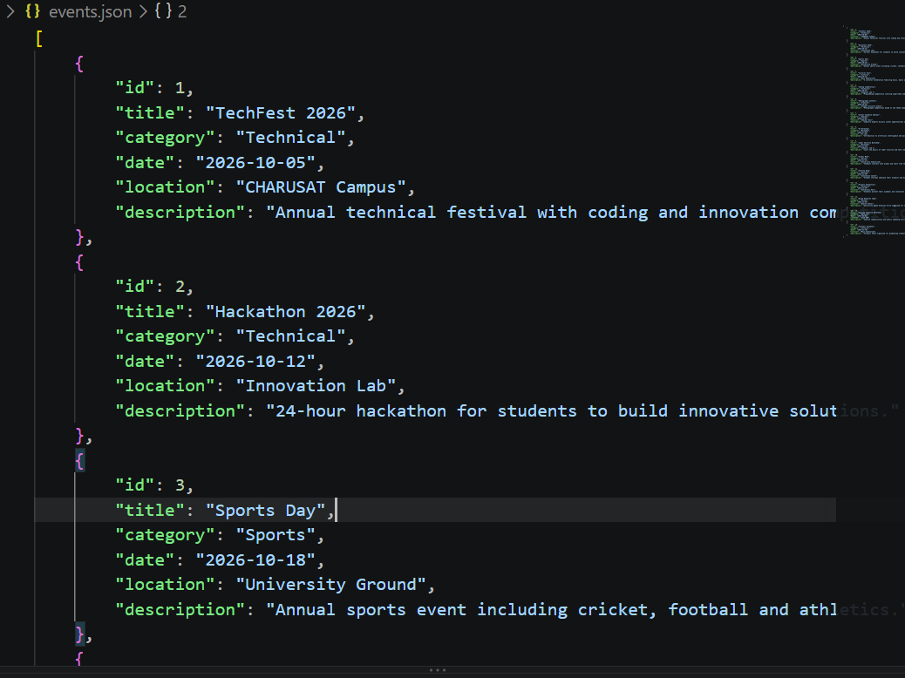
Description : Json file that has data of events

Figure 1.2 Event page
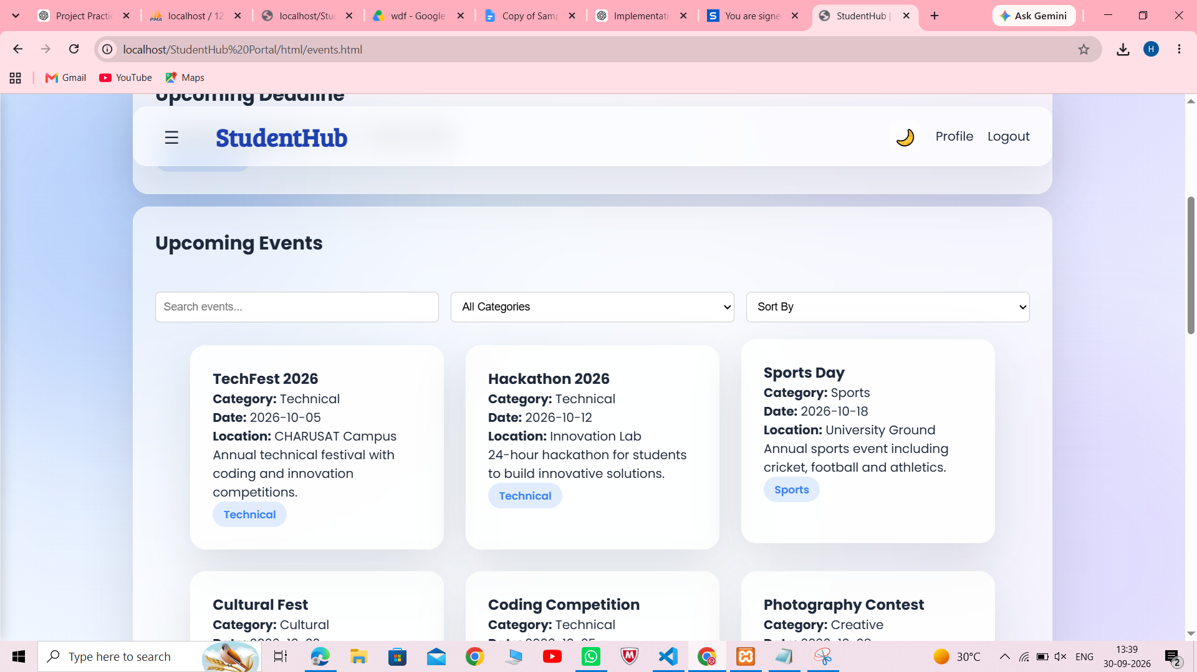
Description: Events displayed from json file
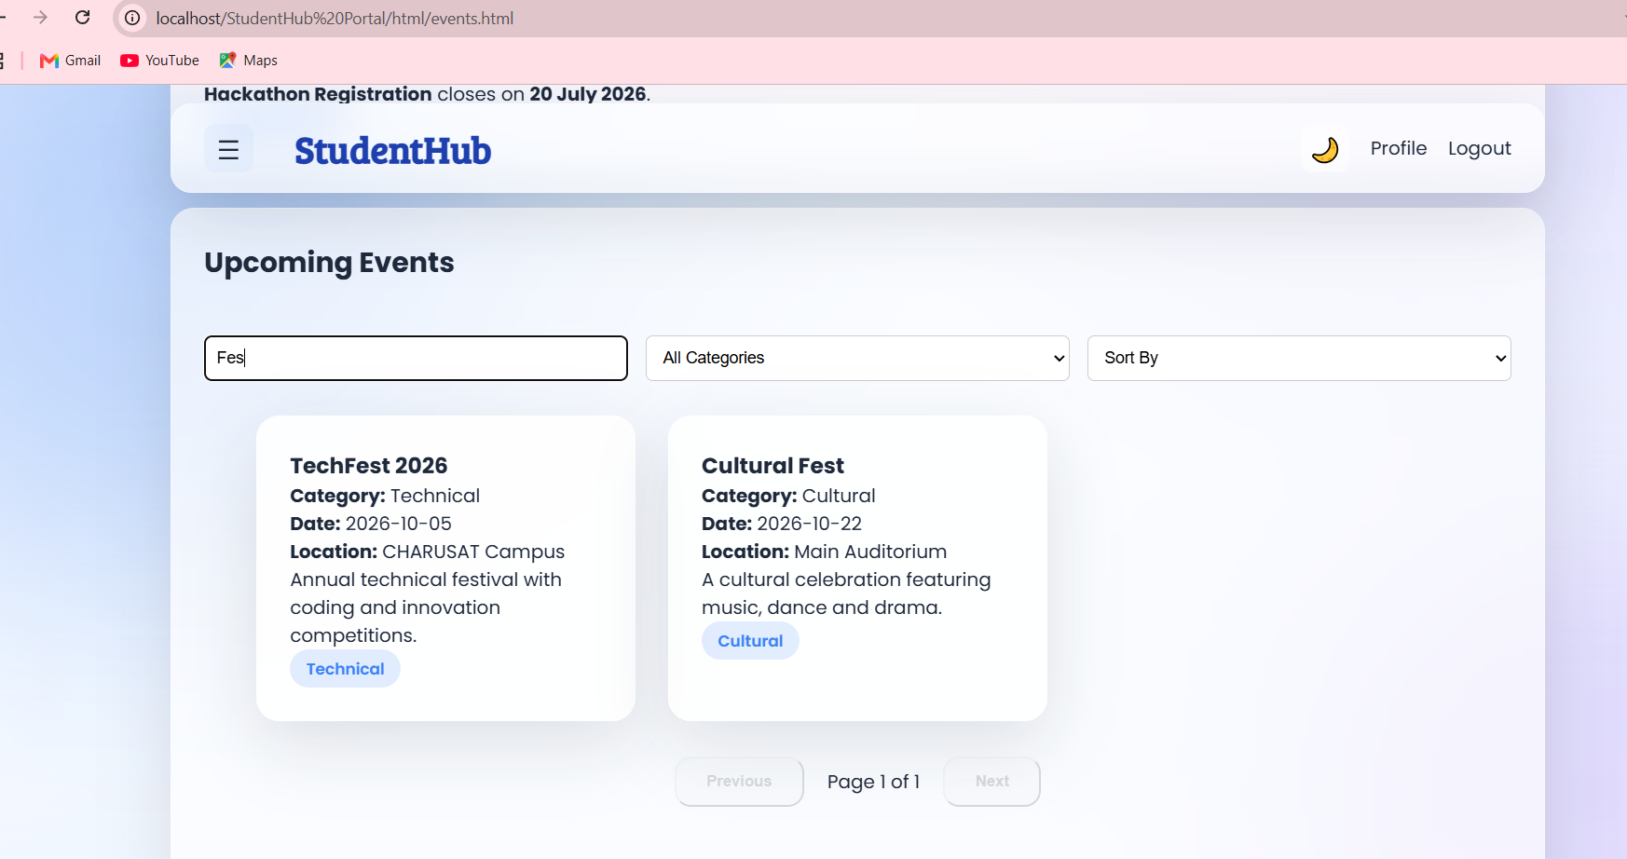
Description: Search Functionality

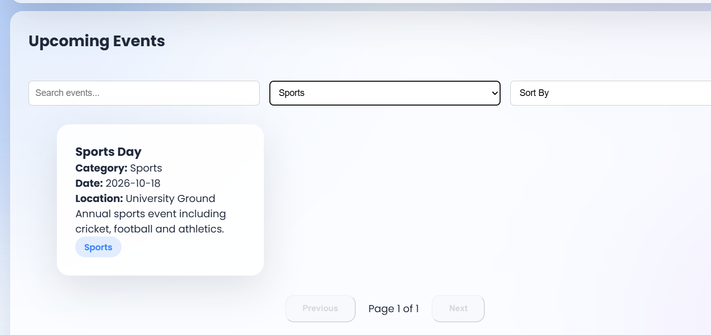
Description: Category wise filtering

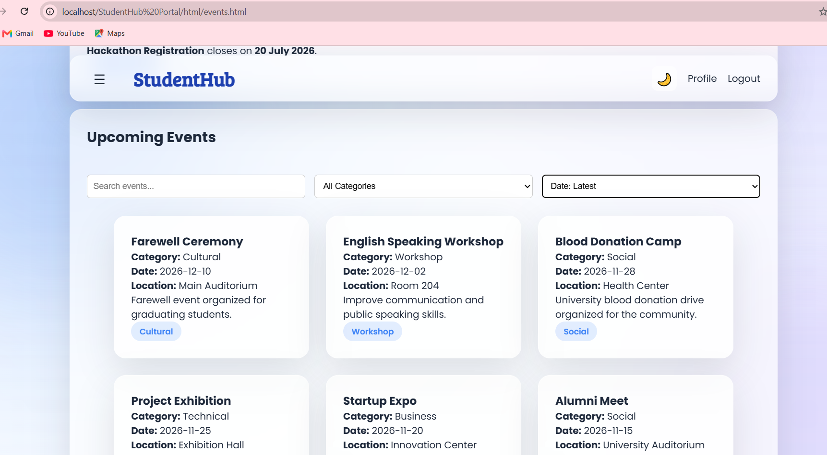
Description: Sorting

GitHub Repository Link:
https://github.com/heerce27/StudentHub-Portal.git

Challenges Faced:
Initially, I faced difficulty in fetching the JSON files correctly because of incorrect file path , but that was done correctly afterwords.

Learning Outcomes:

Learned how to fetch and use external JSON data with the Fetch API.

Learned how to parse JSON and dynamically display data using JavaScript.

Understood the use of map(), filter(),sort() and array slicing for data manipulation.

Learned how to implement search, filtering in a web page.

Understood how to handle loading and error states in a web application.

Learned how to organize JavaScript code into reusable functions.

Gained practical experience in creating dynamic and reusable frontend views.

Faculty Remarks:

